Operating Systems 2 (CS3523) Quiz 1

SURAJ TELUGU

CS20BTECH11050

3sol

To minimise average response time the processes, have to be scheduled in order of their shortest run times (shortest job first algorithm).

if(X<3) {Shortest run time order is X,3,5,6,9}

else if(3<X<5) {Shortest run time order is 3,X,5,6,9}

else if(5<X<6) {Shortest run time order is 3,5,X,6,9}

else if(6<X<9) {Shortest run time order is 3,5,6,X,9}

else if(X>9) {Shortest run time order is 3,5,6,9,X}

4sol

The CPU utilization of process P1 = t1/p1 = 25/40 = 0.625

The CPU utilization of process P2 = t2/p2 = 30/75 = 0.4

Total CPU utilization of processes P1, P2 = 0.625 + 0.4 = 1.025 (Not possible)

The CPU utilization of rate monotonic scheduling is limited and for 2 processes the total CPU utilization should be less than 83% for scheduling using rate monotonic scheduling algorithm.

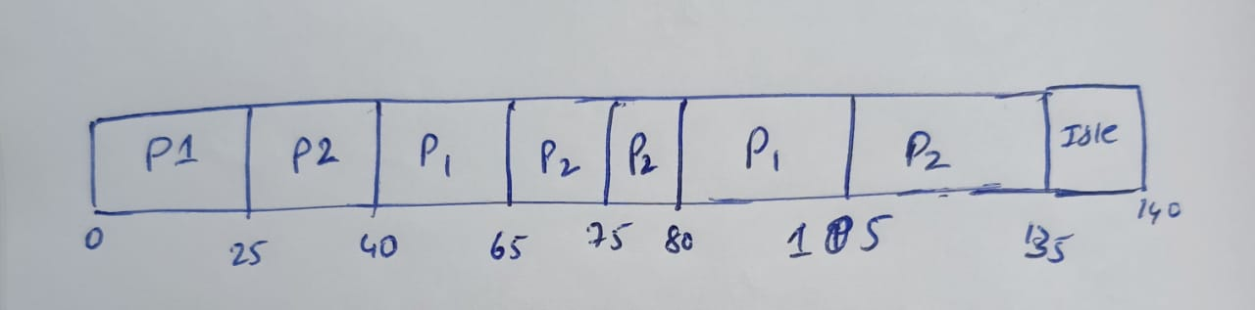

In the above Gantt chart P2 missed its first deadline by 5 sec. Hence from above Gantt chart we can say that P1, P2 **cannot be scheduled** using rate monotonic scheduling.



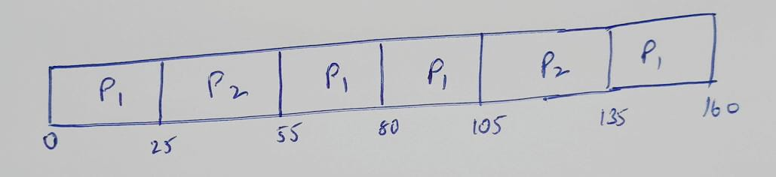

This process can be scheduled using earliest deadline first as shown above. Since P1 has short period in an interval of 160s P1 can run 4 times where as P2 runs 2 times only. In second step since P1 deadline is 80 and P2 deadline is 75 so process P2 was chosen after P1 as per EDF scheduling algorithm.

5sol

We know that for scheduling successfully in rate monotonic scheduling the total CPU utilization time must be at most N(2^(1/N) -1)

Given Number of tasks = 5

RMS Max CPU utilization = 5*(2^(1/5) -1) = 0.7435 = 74.35%

Therefore for 5 tasks CPU utilization can be utmost 74.35%

The CPU utilization of task P1 = C1/T1 = 20/90 = 0.2222

The CPU utilization of task P2 = C2/T2 = 30/250 = 0.1200

The CPU utilization of task P3 = C3/T3 = 70/370 = 0.1892

The CPU utilization of task P4 = C4/T4 = 50/330 = 0.1515

The CPU utilization of task P5 = C5/T5 = 125/2000 = 0.0625

Total CPU utilization time of all the 5 tasks = 0.2222+0.1200+0.1892+0.1515+0.0625

= 0.7454 = 74.54%

Since the maximum CPU utilization is less than total CPU utilization of tasks these 5 tasks the above tasks cannot be scheduled using RMS scheduling algorithm.

1sol

Let the 5 processes be P1, P2, P3, P4, P5

|  |  |  |
| --- | --- | --- |
| Process | Run Time | Priority |
| P1 | 15 | 6 |
| P2 | 9 | 3 |
| P3 | 3 | 7 |
| P4 | 6 | 9 |
| P5 | 12 | 4 |

(a)

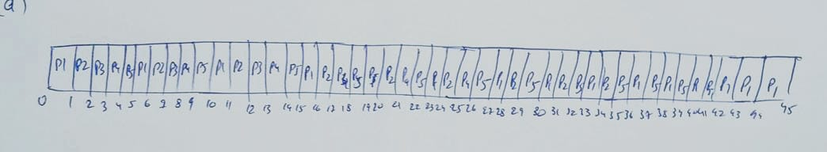

Using round robin scheduling algorithm

|  |  |
| --- | --- |
| Process | Turnaround time |
| P1 | 45 |
| P2 | 26 |
| P3 | 13 |
| P4 | 36 |
| P5 | 42 |

Average turnaround time using RR = 32.4 minutes

(b)

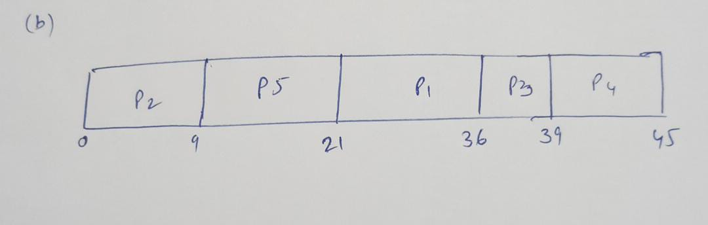

Using priority based scheduling algorithm

|  |  |
| --- | --- |
| Process | Turnaround time |
| P1 | 36 |
| P2 | 9 |
| P3 | 39 |
| P4 | 45 |
| P5 | 21 |

Average turnaround time using PBS = 30 minutes

(c)

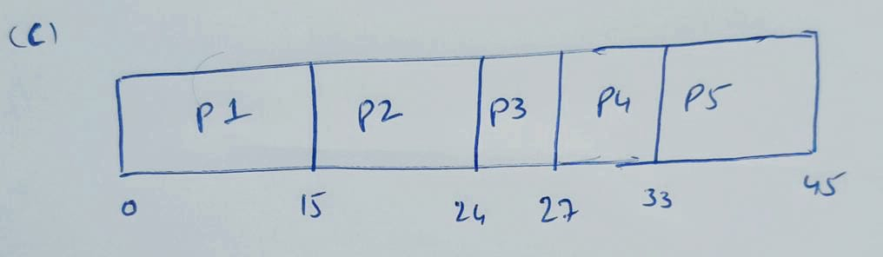

Using FCFS scheduling algorithm

|  |  |
| --- | --- |
| Process | Turnaround time |
| P1 | 15 |
| P2 | 24 |
| P3 | 27 |
| P4 | 33 |
| P5 | 45 |

Average turn around time using FCFS = 28.8 minute

(d)

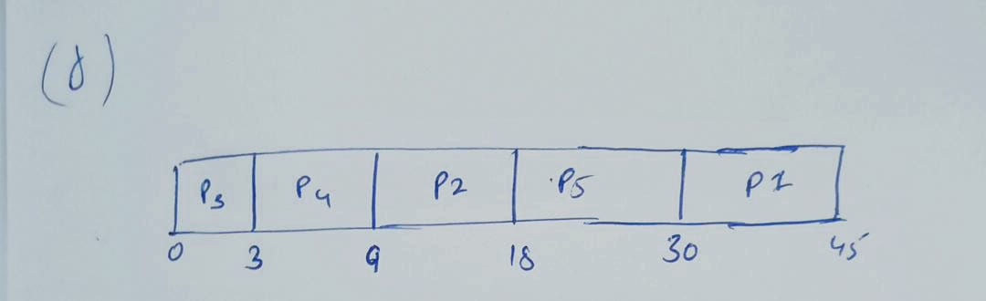

Using SJF scheduling algorithm

|  |  |
| --- | --- |
| Process | Turnaround time |
| P1 | 3 |
| P2 | 9 |
| P3 | 18 |
| P4 | 30 |
| P5 | 45 |

Average turnaround time using SJF = 21 minutes

2sol

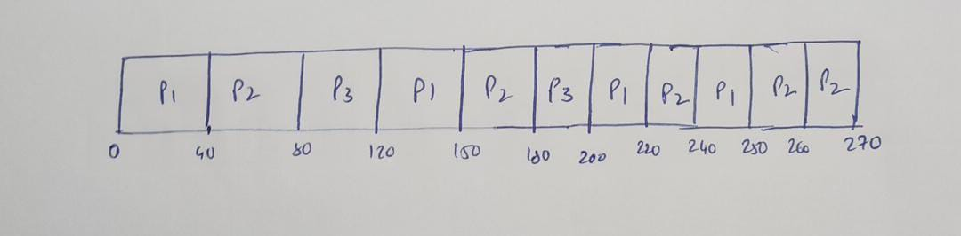

|  |  |
| --- | --- |
| Process | Waiting time |
| P1 | 50 |
| P2 | 150 |
| P3 | 140 |
|  |  |

Average waiting time = 113.33 sec

Advantages :

1. Without assigning priorities we can divide the processes into I/O bound and CPU bound
2. We can make the system more user interactive than normal RR

Disadvantages:

1. This may lead to large waiting time even for small processes like above
2. With only small time processes this algrorithm gives large waiting time for each process